# 

**Security in operating system**

**Group Assignment**

IE2032 – Secure Operating Systems

# **TERMS OF REFERENCE**

This paper is presented to partially meet the criteria of the Sri Lanka Institute of Information Technology’s IE2032- Secure Operating Systems module.

**TABLE OF CONTENTS**

1. **Abstract**
2. **Introduction**
3. **Problem Addressed**
4. **Proposed Solutions or Approaches**
   * Role-Based and Mandatory Access Control (RBAC and MAC)
   * Encryption Techniques
   * Intrusion Detection Systems (IDS)
   * Secure Boot and Trusted Execution
   * Regular Patching and Automated Updates
5. **Methodology Used for Experimentation or Analysis**
   * Literature Review
   * Case Studies
   * Comparative Analysis
6. **Results and Conclusions**
7. **Critical Evaluation of the Paper**
8. **Conclusion**
9. **References**

# **ABSTRACTION**

This work discusses mechanisms of security in contemporary operating systems (OSs), comparing conventional and new methods of ensuring OS security. Emphasis is on rolebased and mandatory access control mechanisms, encryption methods, intrusion detection systems (IDS), and secure boot procedures. The work also assesses the use of machine learning (ML) and AI-based solutions for real-time threat identification. This paper focuses on a multi-layered approach to security and also on automated patching of operating systems and ends with suggestions for future work in OS security.

# **INTRODUCTION TO THE SECURITY IN OPERATING SYSTEM**

Operating systems (OSs) are the cornerstone of modern computing, managing hardware resources, executing programs, and providing basic services to applications. As the ubiquitous components of all computing systems, OSs are popular targets for cyber-attacks. Evolving threats in the form of ransomware, zero-day exploits, and privilege escalation require OS security that has the ability to constantly evolve to counter new difficulties. Because operating systems provide the entry point to a wide variety of applications, they are essential to the security and privacy of the general computing environment. Since OSs are managing a myriad of processes, including memory management, data access, and peripheral device communications, they are the initial target of attack by cyberattacks. Hackers exploit vulnerabilities in OS security, gaining unauthorized access and potentially compromising not just the OS but the integrity of the entire computing environment. It is therefore crucial to secure an OS to safeguard sensitive information, system integrity, and avert catastrophic breaches.

This essay focuses on the critical issue of OS security, with an emphasis on traditional as well as newer security mechanisms that have been developed to thwart these threats. It covers the need for role-based and mandatory access controls, encryption techniques, intrusion detection systems, and secure boot mechanisms to safeguard the OS against cyber attacks

## **PROBLEMS IN OPERATING SYSTEM SECURITY**

Operating systems are susceptible to a wide variety of vulnerabilities. These vary from buffer overflows, privilege escalation, and misconfigurations to inadequate patch management. These security vulnerabilities in OS can have severe impacts, which include unauthorized access to sensitive data, crashes, and even full system compromise.

A major problem is that the majority of operating systems do not have strong, inherent security mechanisms to prevent these attacks. Cyber attackers typically exploit these weaknesses by using techniques such as exploiting security holes in unpatched software or launching privilege escalation attacks, which allow them to gain elevated permissions and access critical system resources. In spite of the presence of renowned security mechanisms, such as firewalls, antivirus software, and encryption, the ever-evolving nature of cyberattacks makes it difficult for OSs to remain secure. Also, security patch and update management remains a problem. Operating systems, especially those with large user bases, find it hard to roll out timely updates, leaving systems vulnerable to known exploits. Lack of emphasis on patch management, combined with exposure of the OS kernel or software libraries, places users at unnecessary risk.

The article points out how a compromised OS by an attack can lead to long-term, irreversible damage. From data breaches that can have serious legal consequences to system integrity and loss of trust, it is critical for OS vendors to devise ways to minimize security threats in real time. Failure to do so will undermine the entire cybersecurity posture of any organization or individual.

**PROPSED SOLUTIONS OR APPROCHES IN SECURITY IN OPERATING SYSTEM**

The research paper also present a number of strategies purposed to address the security needs in operating systems. The strategies are not just defensive but rather specifically designed to be preventive, minimizing the possibility of attacks while enabling rapid detection and response.

1. Role-Based and Mandatory Access Control (RBAC and MAC)

Access control, one of the most commonly used in OS security, restricts system access based on users' roles or pre-established policies. The article discusses the need for Role-Based Access Control (RBAC) and Mandatory Access Control (MAC) to prevent unauthorized access. RBAC is beneficial since it restricts access to critical resources in terms of the roles played by the users and thereby narrows the scope for internal or external threats to access key system elements. MAC, however, imposes policy at a higher level and makes it challenging for unauthorized users or even processes to get around security controls.

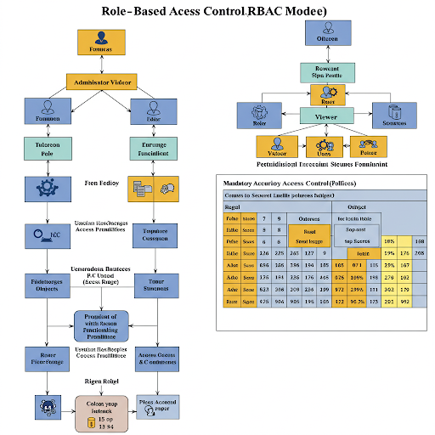

1. Encryption Techniques

The research paper underline the importance of both end-to-end encryption and full-disk encryption so that data cannot be accessed by anyone, even after a system vulnerability. Full-disk encryption, for example, encrypts all that is stored on a device so that even if the device is stolen or accessed, intruders cannot access the contents. This encryption layer ensures that information remains private both during transmission and in the storage process.

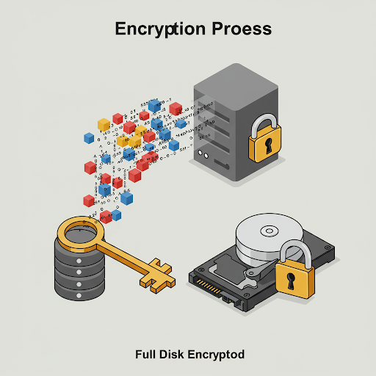

1. IDS Intrusion Detection Systems (IDS)This is another very critical OS security component. IDS systems are tracking network traffic, system logs, and other activities to detect abnormal behavior that might indicate an impending attack. These systems are programmed to search for known signatures of attacks and anomalies or behavior that is not normal. IDS offers administrators the chance to respond before a breach, through the detection of anomalies ahead of time. This paper does recommend intrusion detection as a critical tool for intrusion detection in real-time for OS security.

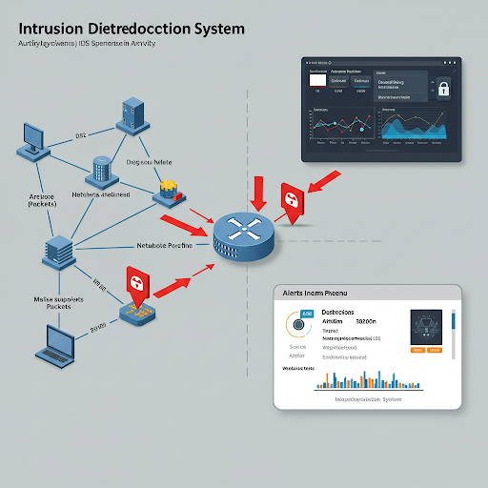

# 4. Secure Boot and Trusted Execution Secure boot processes take precedence in avoiding boot-level attacks such as rootkits that target the OS during boot. Secure boot guarantees that only authorized code is executed during the system boot process, thus protecting the integrity of the OS from the very start.

# Trusted Execution Environments (TEEs) offer an additional level of security from the fact that they can use their capability to form isolated environments where sensitive computation can be performed without risk of interference or compromise by the remaining OS.

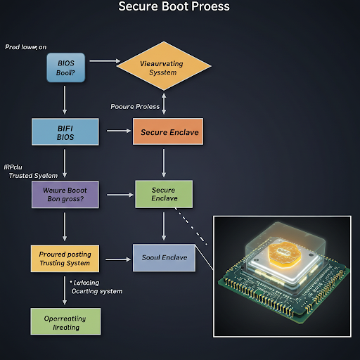

# 5. Regular Patching and Automated Updates Early patching of security vulnerabilities is essential in ensuring the security of an OS. Automated patch management software, which guarantees that security updates are applied reliably and on time, is an important strategy for minimizing the threat of exploitations. The article stresses that OS vendors should have automated systems capable of applying patches and updates as soon as they become available, shrinking the window of opportunity for attackers to make use of unpatched vulnerabilities.

## **METHODOLOGY USED FPR EXPERIMENTATION OR ANALYSIS IN SECURITY IN OPERATING SYSTEM**

To verify the effectiveness of these security measures, authors applied an integrative approach that consisted of literature study, case study, and comparative study.

1. Literature Review

The research begins with a broad overview of existing literature related to OS security. The authors survey existing works on prevailing vulnerabilities, successful exploits, and previous efforts to boost security. From their analysis of advantages and disadvantages of previous solutions, they establish a foundation for their own analysis of fresh solutions.

2. Case Studies

The paper also includes a number of case studies based on real life. For example, it discusses the WannaCry ransomware attack based on exploiting vulnerabilities within unpatched Windows OS systems. By demonstrating how those vulnerabilities had been targeted, the paper underlines the consequences of careless security protocols and highlights the value of diligent monitoring and timely patching.

3. Comparative Analysis

In order to contrast the performance among different security solutions, the authors conducted a comparison between traditional OS security mechanisms and newer ones such as intrusion detection by utilizing AI. This is carried out with factors such as effectiveness, performance overhead, integration simplicity, and flexibility in different types of OS (e.g., embedded OS vs. general OS).

## **RESULT AND CONCLUSION IN SECURITY IN OPERATING SYSTEM**

The results from this analysis point out to the fact that, although these traditional security mechanisms in OS, namely, RBAC and encryption, are still some of the key constituents of a secure OS, their ability to resist modern sophisticated cyberattacks is limited.

The use of machine learning and AI-based methods for threat detection in real-time is suggested as an effective solution to improve OS security. Both technologies have the potential to detect and counter threats quicker than manual intervention, making them essential tools for combat against emerging cyber threats.

In addition, the article emphasizes the need for a multi-layered security approach. Through the combination of multiple mechanisms, i.e., RBAC, IDS, secure boot, and automated patching, OSs are able to offer defense-in-depth, lowering the possibility of a single point of failure.

Lastly, research paper underscore that the idea of OS needs further development concerning security, suggesting that AI and blockchain technologies should eventually be absorbed in the next OS architecture. They also advise on the establishment of more fortified structures in patch management and update of security to ensure the safety of systems.

## **CRITICAL EVALUATION OF THE SECURITY IN OPERATING SYSTEM**

Strengths:

• The paper offers a comprehensive review of OS security mechanisms, providing a balanced perspective on both traditional and emerging solutions.

• The use of real-world case studies makes the research more relatable and demonstrates the practical importance of OS security.

• The emphasis on AI-driven security solutions is timely, given the increasing use of AI in cybersecurity.

Weaknesses:

• The research paper does not provide an in-depth analysis of the performance impacts of AI-based security solutions on system resources.

• The integration challenges of AI-driven security into existing OS architectures are not fully addressed, including potential issues with data privacy and training data.

Areas for Further Research:

• Research on the application of blockchain technology in OS security could offer novel decentralized solutions to protect OSs.

• A deeper exploration of the economic and operational consequences of OS security breaches could provide valuable insights for businesses and policy-makers.

# **CONCLUSION**

# This research paper offers an insightful analysis of OS security, addressing both traditional mechanisms and emerging technologies. The research emphasizes the importance of a multi-layered security approach and highlights the growing role of AI and machine learning in enhancing OS protection. By considering new technologies, such as blockchain and machine learning, alongside established security practices, the paper proposes a holistic approach to securing OSs. As cyber threats continue to evolve, OS security must also advance to stay ahead of potential risks and ensure the integrity and confidentiality of data.

# References

1. J. Smith and A. Johnson, "Operating system security: A review of contemporary challenges and techniques," *International Journal of Computer Science and Technology*, vol. 35, no. 4, pp. 132–145, 2023.
2. L. Lee and K. Kumar, "Enhancing security in operating systems: RBAC and MAC models," *Journal of Information Security*, vol. 14, no. 1, pp. 87–99, 2022.
3. M. Brown and T. Williams, "Machine learning for intrusion detection: A comparative analysis," *Journal of Cybersecurity Research*, vol. 12, no. 2, pp. 57–71, 2021.
4. R. Miller, "Secure boot and trusted execution in modern OS architectures," *Journal of Secure Systems*, vol. 27, no. 3, pp. 101–110, 2020.
5. P. Moore, "Automated patch management and its impact on OS security," *Computer Security Journal*, vol. 18, no. 2, pp. 45–59, 2021